**IAM Project – Fundamental**



**Student Name: Berkay Yılmaz**

**Program : Exchange**

1. **Subject Description**

The Identity Management Software is builded to manage users of an Information System. This software can provide features such as storing identity informations and manage them. One who is logged in can create, delete and modify identities with a basic and simple interface. Also admins can create new admins.

1. **Subject Analysis**
2. **Major Features**
   1. Access, create and modify user information
   2. Persist users data in a database
   3. Robust, efficient
   4. Simple interface
3. **Application Feasibility**
   1. **Strengths**
      1. Database
      2. Secured Admin Login
   2. **Weakness**
      1. Little amount of information about identities
      2. Two kind of identity(Normal, admin)
      3. Database is local.
4. **Data Description**
5. Identity: Which has Login name and email.
6. User: Which has login name, email and password. User is also Identity.
7. Only users and root can change anything in database.
8. Program has its own menu.
9. **Expected Results**
   1. Admins can create, delete and modify identities.
   2. Informations can be stored in database.
10. **Scope of the Application**

Application can be used in every areas which have group hierarchy. Application can be used for other kind of identities and can store more information. It can be used for even banks.

1. **Conception**
2. **Choosen Algorithm**

At the beginning of the program. There is just root which has username of “adm” and password of “pwd”. This root cannot be deleted and changed in any circumstances.

In order to login the information you gave need to be in database with a password. When you create an admin you put password. The identities which has no password cannot login.

The Identity who logged in can change all Identities even other Admins.

1. **Data Structures**

* ArrayList
* Token

1. **Global Application Flow**

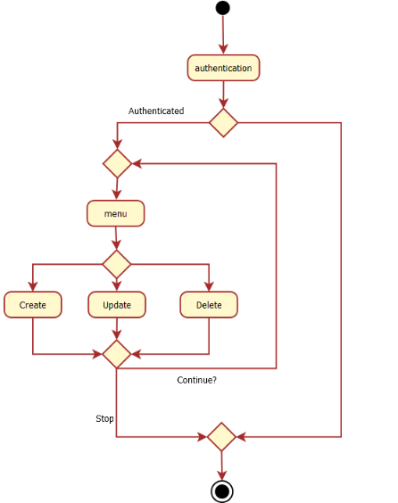

1. **Global Schema**

**C:\Users\Yasin\Downloads\Untitled Diagram.png**

1. **Console Operations Description (ScreenShots)**

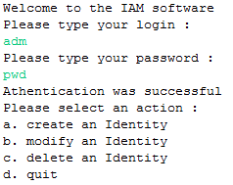

If user choose a to create an identity there are two types of creating an Identity (Identity or Admin)

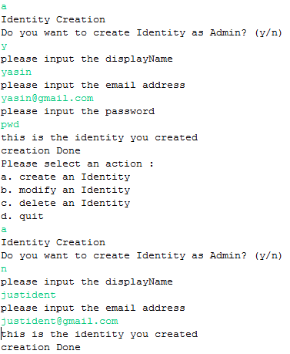

If user choose b to modify an user: 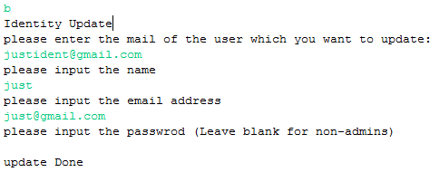

If user choose c to delete an user:

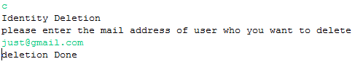

If user choose to exit:

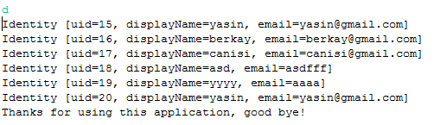

1. **Configuration Instructions**
2. **Bibliography**

**a.** http://thomas-broussard.fr/work/java/courses/project/fundamental.xhtml